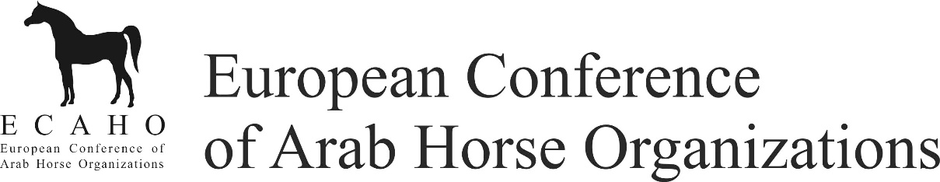

ECAHO Breeders´ Fund - PAYMENT CONFIRMATION

Event:
Date:
Organizer:
Amount: 200 € per horse
Payment method: in cash to horse owner

By accepting the cash money and signing of this document I confirm that:
- I am the legitimate owner of the below mentioned horse.
- I am responsible for complying with all income tax laws applicable in my country of residence.
- I agree to the Privacy Policy as published on ECAHO's website (www.ecaho.org).

Class | Ranking | Horse no. | Horse name | Horse and account owner’s name only | Horse and account owner’s signature only
Class | Ranking | Horse no. | Horse name | Horse and account owner’s name only | Horse and account owner’s signature only
Class | Ranking | Horse no. | Horse name | Horse and account owner’s name only | Horse and account owner’s signature only
Class | Ranking | Horse no. | Horse name | Horse and account owner’s name only | Horse and account owner’s signature only

Total amount paid by ECAHO: € _____________________

Date:

Stamp & signature show organizer Stamp & signature ECAHO

